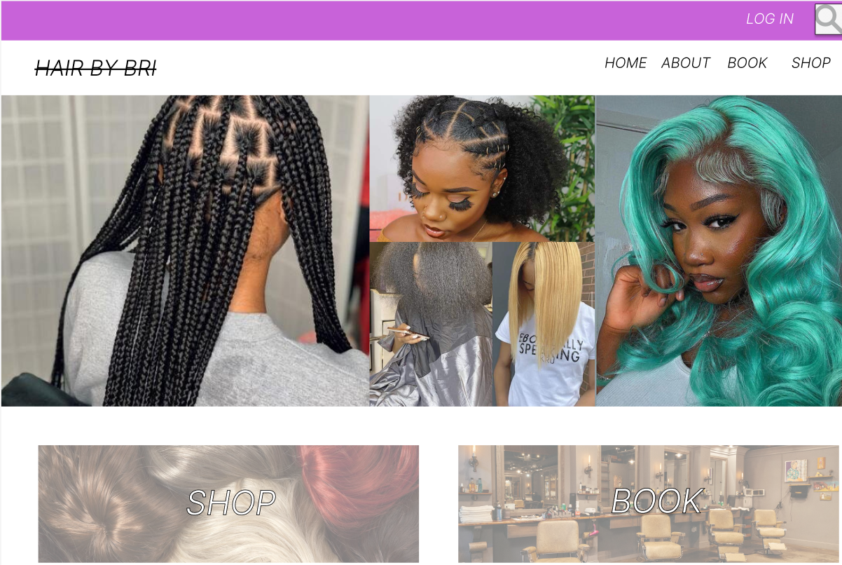

The customer is able to shop with the owner

The customer is able to see what the site/owner is about. The owner is also able to update the site.

This allows the user to book with the owner

This feature allows the user to return home.

Consumer is able to search for products.

***FEATURES***

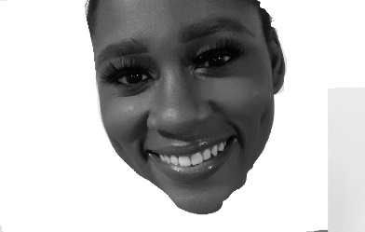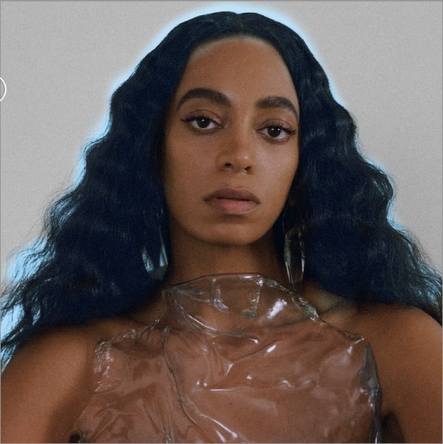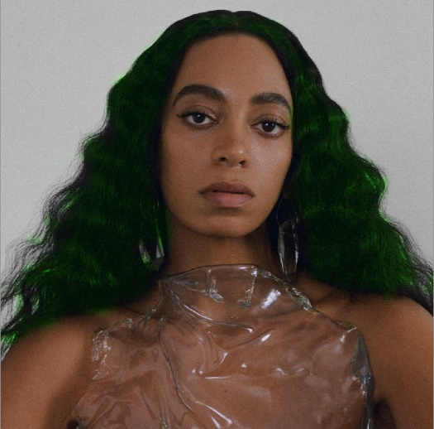

CHANGE



The consumer is able to change the model’s hair color and is able to add in their photo.

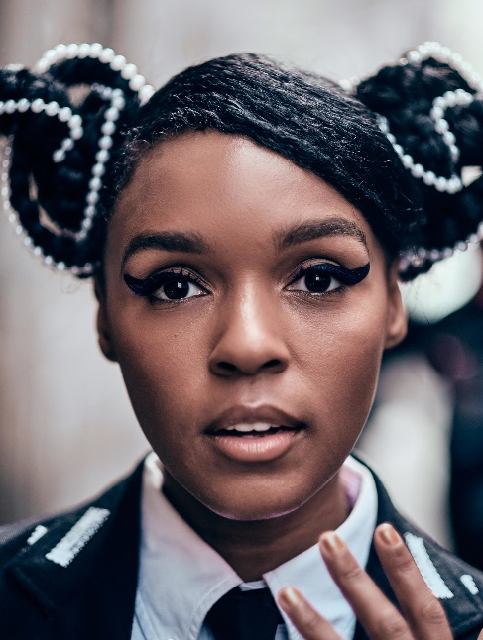

Braids with buns

* The user is able to search up hairstyles into the search engine.
* The user can also add their photo these pictures

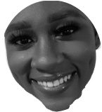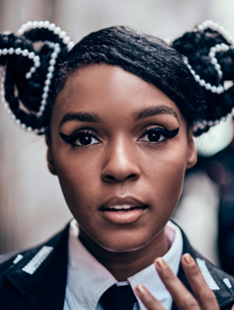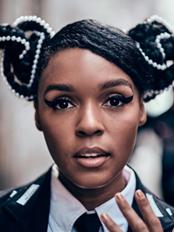

ADD PHOTO